**New to Seed Saving?**

Start with seeds that are labeled “easy.” These seeds are great for beginners and produce plants like the ones you planted.

We recommend you start with these:

|  |  |  |
| --- | --- | --- |
| * basil * beans * beets * carrots * chard | * eggplant * leeks * lettuce * onions * parsley | * peas * peppers * spinach * sunflowers * tomatoes |

The seeds that are labeled “advanced” require special planning to preserve varietal purity. If certain precautions are not taken with them, then the next grower will not get the same plant. We want to ensure that the seeds that you return to the library are indeed what they claim to be. So please borrow “advanced” seeds only after you have learned about isolating plants to prevent cross-pollination.

**Library Organization**

The library is organized by plant families.

The system is color-coded and corresponds to the families listed on the **Planting Times** chart, which is posted in the Seed Library and on our website.

Each drawer is labeled “easy” or “advanced” with family names and some common members of the family. For example, *Lily Family: chives, garlic, leek, onion.* There are dividers for each plant in the drawer. Seeds are alphabetical behind the dividers.

**How to Borrow Seeds**

1. Using the Seed Stamp, stamp and fill out a separate envelope for each type of seed you plan to take.
2. Put seeds in envelopes.

***Example Seed Stamp***

If you are looking for seeds for a particular plant and can’t find them, then look up their family name in the **Plant Index**, which is available at the Seed Library and online.

|  |  |  |  |  |  |
| --- | --- | --- | --- | --- | --- |
| **Green Thumbs, Green Minds**  **Seed Lending Library** | | | | | |
| Common name: | | | | Tomato | |
| Scientific name: | | | | *Solanum lycopersicum* | |
| Variety: | | Brandywine | | | |
| Seed Source: | | | Joe Smith | | |
| Location of harvest: | | | | | Alameda |
| Year: | 2011 | | | | |
| Notes: | Original seed from Baker | | | | |
| Creek. Dry farmed. Great-tasting. | | | | | |
| Difficulty of saving seed: | | | | | |
| þ Easy o Advanced | | | | | |
| Thank you for saving seeds!  **Please return some seeds at the end of the season.**  Visit alamedafree.org | | | | | |

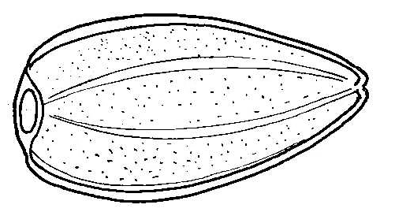  

**How to Donate and Return Seeds**

First, read the Green Thumbs, Green Minds brochure, **How to Save Seeds**.

Once you have collected seed from your easy-to-save crops, set aside some for yourself and some for the library in clearly labeled containers.

Seeds for the library should be in envelopes labeled with the Seed Stamp. You can stamp your envelopes when you’re at the library, or you can print out a label at home from the website.

If you haven’t done so yet, fill out the membership form on the computer at the library.

Bring your labeled seeds to the Library. Find the appropriate drawer and section for your seeds. Put your envelope behind the label for the plant. Within each divider, place seeds alphabetically. Refer to the Plant Index for scientific names.

**Learn More**

* visit *www.alamedafree.org*
* take seed saving classes
* join the *seedsavers.org* forum
* read about seed saving at your local library
* talk to experienced seed-saving gardeners
* keep good garden records

**Welcome to the World of Saving and Sharing Seeds!**

**Borrowing Seeds**

The seeds you borrow from Green Thumbs, Green Minds are lent to you at no financial cost, and **they are priceless.**

A commitment to growing plants from seeds is a gift to you. We hope you learn much, experience the joy of gardening, and enjoy the fruits of your labor.

At harvest time, please take some extra steps to save seeds for others. We ask that a portion of the seeds you save be returned to the seed lending library to keep the library self-sustaining. The more seeds in the library, the more members of our community can experience the pleasures of growing their own food.

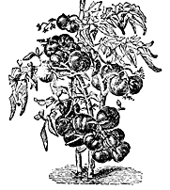

**Why Save Seeds?**

Humans have been saving seeds for over 12,000 years. However, in our culture much of that knowledge has been lost over the last hundred years, along with significant biodiversity. When you grow and save your own seeds, you

* develop seed stock that is well suited to our climate
* save money
* mitigate our dependence on agro-business

When you participate in the seed library, you create a culture of sharing and abundance.

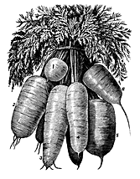

***The seed is hope; the flower is joy.***

*-  Author Unknown*

**Support Green Thumbs, Green Minds**

Green Thumbs, Green Minds is supported by volunteers and donations. Please contact us at refdesk@alamedaca.gov.

**Welcome to**

**The Seed Library!**

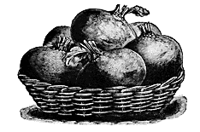

**Green Thumbs, Green Minds**

**OUR MISSION:**

Green Thumbs, Green Minds is dedicated to increasing library usage and community involvement, food independence in Alameda, transmission of knowledge from one generation to the next, and the diversity of edible plant life and nurturing strains suited to Alameda’s specific environment.

Located in the Alameda Free Library  
1550 Oak Street

Alameda, CA  94501

*www.alamedafree.org*

Monday, Tuesday 10-8, Wednesday 12-8 Thursday-Saturday 10-5

Sunday 12-5

Holidays closed